d Relie

|  |  |  |
| --- | --- | --- |
| ciseaux |  | **cartable** |
| cahier |  | **ciseaux** |
| cartable |  | **colle** |
| colle |  | **cahier** |
| crayon |  | **crayon** |

# 

## n Dessine

# Un stylo

# Une règle

# Une trousse

Un cahier

# De la colle

h Entoure le mot

# cartable trousse ciseaux

livre

crayon cahier classeur colle

stylo crayon règle gomme

crayon colle

gomme

cartable crayon classeur

q Ecris

la gomme . .

la colle . .

## h Entoure le mot

# cartable trousse ciseaux

livre

cartable cahier cartable colle

stylo cartable règle gomme

crayon taille-crayon

gomme

cartable cartable classeur

**à et é Colle les dessins qui correspondent aux mots**

|  |  |  |  |
| --- | --- | --- | --- |
| Le cartable |  | Des ciseaux |  |
| Une trousse |  | La colle |  |

|  |  |  |  |
| --- | --- | --- | --- |
| ~AUT0005 |  | ~AUT0008 | ~AUT0013 |

q Ecris

une trousse . .

un cartable . .

i Colorie les lettres des mots suivants :

cartable

|  |  |  |  |  |  |  |  |  |  |  |  |  |  |  |  |  |  |  |  |  |  |  |  |  |  |
| --- | --- | --- | --- | --- | --- | --- | --- | --- | --- | --- | --- | --- | --- | --- | --- | --- | --- | --- | --- | --- | --- | --- | --- | --- | --- |
| a | b | c | d | e | f | g | h | i | j | k | l | m | n | o | p | q | r | s | t | u | v | w | x | y | z |

trousse

|  |  |  |  |  |  |  |  |  |  |  |  |  |  |  |  |  |  |  |  |  |  |  |  |  |  |
| --- | --- | --- | --- | --- | --- | --- | --- | --- | --- | --- | --- | --- | --- | --- | --- | --- | --- | --- | --- | --- | --- | --- | --- | --- | --- |
| a | b | c | d | e | f | g | h | i | j | k | l | m | n | o | p | q | r | s | t | u | v | w | x | y | z |

stylo

|  |  |  |  |  |  |  |  |  |  |  |  |  |  |  |  |  |  |  |  |  |  |  |  |  |  |
| --- | --- | --- | --- | --- | --- | --- | --- | --- | --- | --- | --- | --- | --- | --- | --- | --- | --- | --- | --- | --- | --- | --- | --- | --- | --- |
| a | b | c | d | e | f | g | h | i | j | k | l | m | n | o | p | q | r | s | t | u | v | w | x | y | z |

**ç Découpe les lettres et reconstitue les mots**

trousse

|  |  |  |  |  |  |  |
| --- | --- | --- | --- | --- | --- | --- |
|  |  |  |  |  |  |  |

trousse

|  |  |  |  |  |  |  |
| --- | --- | --- | --- | --- | --- | --- |
|  |  |  |  |  |  |  |

|  |  |  |  |  |  |  |  |  |  |  |  |  |  |
| --- | --- | --- | --- | --- | --- | --- | --- | --- | --- | --- | --- | --- | --- |
| s | | u | | r | | o | | s | | e | | t | |
| s | | u | | r | | o | | s | | e | | t | |

# d Relie les mots

|  |  |  |  |  |  |  |
| --- | --- | --- | --- | --- | --- | --- |
| cartable |  | trousse |  | colle |  | crayon |
| gomme |  | cartable |  | règle |  | colle |
| trousse |  | stylo |  | crayon |  | règle |
| stylo |  | gomme |  | livre |  | cartable |
| ardoise |  | ardoise |  | cartable |  | livre |

i Colorie les lettres des mots suivants :

gomme

|  |  |  |  |  |  |  |  |  |  |  |  |  |  |  |  |  |  |  |  |  |  |  |  |  |  |
| --- | --- | --- | --- | --- | --- | --- | --- | --- | --- | --- | --- | --- | --- | --- | --- | --- | --- | --- | --- | --- | --- | --- | --- | --- | --- |
| a | b | c | d | e | f | g | h | i | j | k | l | m | n | o | p | q | r | s | t | u | v | w | x | y | z |

crayon

|  |  |  |  |  |  |  |  |  |  |  |  |  |  |  |  |  |  |  |  |  |  |  |  |  |  |
| --- | --- | --- | --- | --- | --- | --- | --- | --- | --- | --- | --- | --- | --- | --- | --- | --- | --- | --- | --- | --- | --- | --- | --- | --- | --- |
| a | b | c | d | e | f | g | h | i | j | k | l | m | n | o | p | q | r | s | t | u | v | w | x | y | z |

ardoise

|  |  |  |  |  |  |  |  |  |  |  |  |  |  |  |  |  |  |  |  |  |  |  |  |  |  |
| --- | --- | --- | --- | --- | --- | --- | --- | --- | --- | --- | --- | --- | --- | --- | --- | --- | --- | --- | --- | --- | --- | --- | --- | --- | --- |
| a | b | c | d | e | f | g | h | i | j | k | l | m | n | o | p | q | r | s | t | u | v | w | x | y | z |

ç et è Découpe et associe les différentes écritures

|  |  |  |
| --- | --- | --- |
|  |  |  |
| la colle | un stylo | une gomme |
|  |  |  |
| une trousse | un crayon | des ciseaux |

|  |  |  |
| --- | --- | --- |
| **un crayon** | **une gomme** | **la colle** |
| **une trousse** | **un stylo** | **des ciseaux** |

ç et è Découpe et colle les dessins au dessus des mots

|  |  |  |
| --- | --- | --- |
|  |  |  |
| un crayon | une trousse | une gomme |
|  |  |  |
| un stylo | la colle | des ciseaux |

|  |  |  |  |  |  |
| --- | --- | --- | --- | --- | --- |
| ~AUT0008 | STYLO | ~AUT0013 | troussebla~AUT0013~AUT0013 | ~AUT0011 | ~AUT0009 |

**à Découpe les lettres et reconstitue les mots**

ciseaux

|  |  |  |  |  |  |  |
| --- | --- | --- | --- | --- | --- | --- |
|  |  |  |  |  |  |  |

ciseaux

|  |  |  |  |  |  |
| --- | --- | --- | --- | --- | --- |
|  |  |  |  |  |  |

|  |  |  |  |  |  |  |
| --- | --- | --- | --- | --- | --- | --- |
| x | u | a | s | i | c | e |
| x | u | a | s | i | c | e |

d Relie les mots et les dessins

|  |  |  |
| --- | --- | --- |
| ~AUT0011 |  | le stylo |
| ~AUT0008 |  | les ciseaux |
| ~AUT0007 |  | le crayon à papier |
| ~AUT0013 |  | la colle |
| ~AUT0005 |  | la gomme |
|  |  | la trousse |
| ~AUT0009 |  | le cartable |

# d Relie les mots

|  |  |  |  |  |  |  |
| --- | --- | --- | --- | --- | --- | --- |
| cartable |  | trousse |  | colle |  | crayon |
| gomme |  | cartable |  | règle |  | colle |
| trousse |  | stylo |  | crayon |  | règle |
| stylo |  | gomme |  | livre |  | cartable |
| ardoise |  | ardoise |  | cartable |  | livre |

|  |  |
| --- | --- |
| ~AUT0005 | une trousse - un cahier - de la colle |
| F:\données du PC portable\mes documents sur D\Clin\vocabulaire\ecole\le matériel d'école\jeux à manipuler\image du matériel d'école\LIVRE.png | des ciseaux - un livre - le cartable - |
|  | des ciseaux - un livre - le cartable - |
| ~AUT0010 | un crayon - une règle - un taille-crayon |
| STYLO | un classeur - un stylo - une gomme |

h Entoure le mot correspondant au dessin

p Ecris

une gomme . . . .

la colle . . .

un livre . . .

qEcris les mots : **le crayon, la gomme, le cahier**

|  |  |  |
| --- | --- | --- |
|  |  |  |
| 1 2 3 | | |

qEcris les mots : **le livre, les ciseaux, la règle la trousse**

|  |  |
| --- | --- |
|  |  |
|  |  |
|  |  |
|  |  |

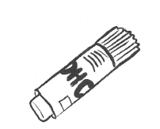ç et è Découpe et colle les mots en écriture cursive

|  |  |  |  |
| --- | --- | --- | --- |
| ~AUT0005 | ~AUT0011 | ~AUT0009 |  |
|  |  |  |  |
| ~AUT0013 | ~AUT0003 |  | ~AUT0012 |
|  |  |  |  |
| F:\données du PC portable\mes documents sur D\Clin\vocabulaire\ecole\le matériel d'école\jeux à manipuler\image du matériel d'école\LIVRE.png | ~AUT0010 | STYLO | ~AUT0020 |
|  |  |  |  |

|  |  |  |  |
| --- | --- | --- | --- |
| la trousse | la gomme | la colle | l‘ardoise |
| le crayon | les ciseaux | le cahier | la règle |
| le livre | le stylo | le taille- crayon | le cartable |

qEcris les mots : **le crayon, la gomme, le cahier, le livre, les ciseaux, la règle la trousse**

|  |  |  |
| --- | --- | --- |
| |  | | --- | |  | | le |
| |  | | --- | |  | | la |
| |  | | --- | |  | | le |
| |  | | --- | |  | | les |
| |  | | --- | |  | | le |
| |  | | --- | |  | | la |
| |  | | --- | |  | | la |

a Barre la lettre qui est en trop :

o s y t b l

s t r

u o e s j

o r c a t a b

l e

c a i r h n e

h a r

o c a

r e

n y

stylo crayon trousse cartable cahier

q Ecris un cartable . .

ç Découpe et è colle les mots

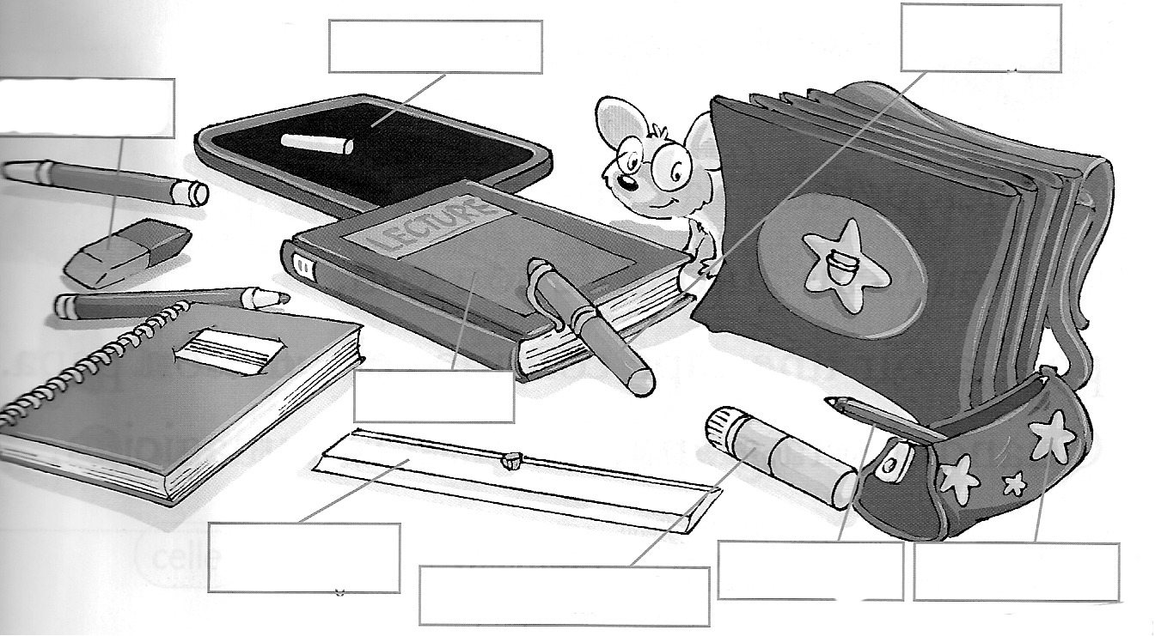

|  |  |  |  |  |
| --- | --- | --- | --- | --- |
| une trousse | un cartable | la colle | un crayon | un livre |
| une règle | une gomme | un stylo | une ardoise | un cahier |

i Colorie les mots du matériel d’école *(attention ils peuvent être écrits plusieurs fois)*

cartable

cahier

règle (2fois)

trousse

colle

gomme (2fois)

crayon

ciseaux

stylo (2fois)

livre (2fois)

|  |  |  |  |  |  |  |  |  |  |  |  |
| --- | --- | --- | --- | --- | --- | --- | --- | --- | --- | --- | --- |
| c | a | h | i | e | r | s | t | y | l | o | t |
| a | s | c | l | b | è | e | u | u | i | c | r |
| r | t | r | i | l | g | o | m | m | e | i | o |
| t | y | a | v | i | l | g | c | y | z | s | u |
| a | l | y | r | v | e | o | o | e | t | e | s |
| b | o | o | e | r | t | m | l | r | r | a | s |
| l | i | n | r | e | e | m | l | l | h | u | e |
| e | w | r | è | g | l | e | e | i | v | x | e |