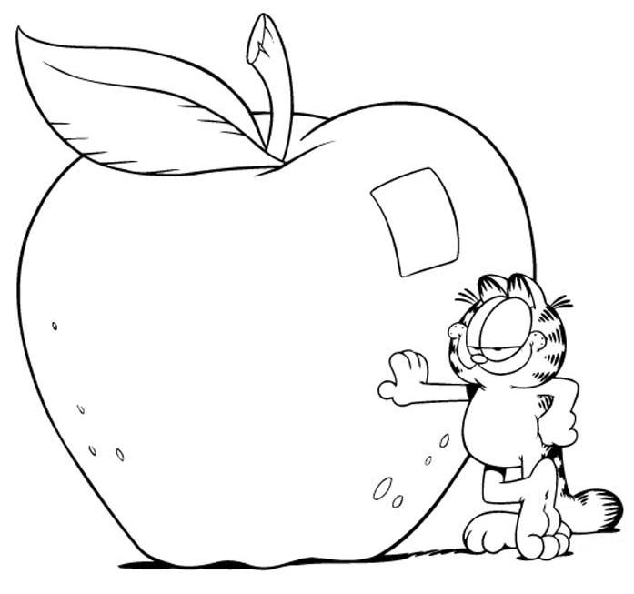



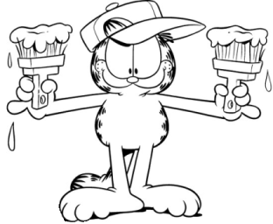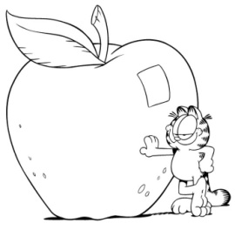

vert

rouge

vert

jaune

bleu

bleu

rouge









|  |  |  |
| --- | --- | --- |
|  |  |  |
|  |  |  |
|  |  |  |
|  |  |  |

|  |  |  |  |  |  |
| --- | --- | --- | --- | --- | --- |
| vert | rouge | bleu | bleu | jaune | rouge |